# Student Database Project

## Introduction

This document provides a comprehensive overview of the Student Registration Database Project. The project involves designing, creating, and using a SQL database that meets specific requirements. The database is designed to manage student registrations in a setting.-

## System Overview

The system includes the following entities: . Each entity has specific attributes and relationships with other entities. The system is designed to handle student registrations, course assignments, and grade management.

|  |  |
| --- | --- |
| ENTITIES | USER |
| student | student |
| teachers | admin |
| staff | teachers |
| administrators |  |
| Class place |  |

## Normalization Explanation

Normalization is the process of organizing the fields and tables of a relational database to minimize redundancy and dependency. The tables in this project are designed to be in 3NF (Third Normal Form), ensuring that each table contains only related data and each non-key attribute is fully functionally dependent on the primary key.

ER Diagram and mapping

Table Structures

The following tables are created in the database: Department, Student, staff, teachers, class place and administrators. Each table has specific columns and data types.  
Each table contains 10 data.They are 5 tables.

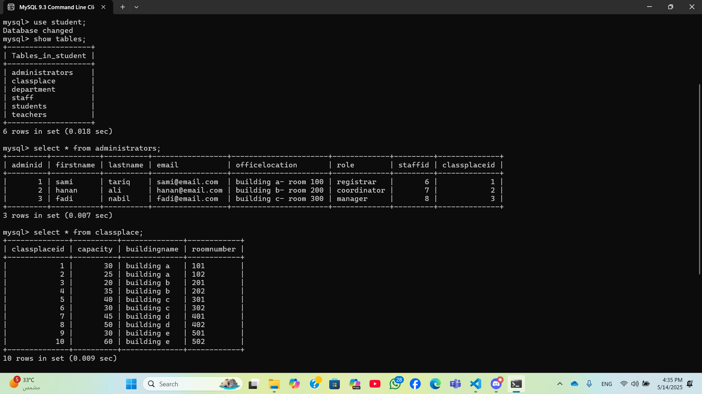

## INQUIRY CODE

## Conclusion

This project demonstrates the design and implementation of a university student registration database. The database is normalized to 3NF and includes various entities and relationships. Sample queries are provided to illustrate the operations that can be performed on the database.